**Objective Questions**

1. **What is the total no. Of tables present in the data?**

Ans. The dataset contains 1 table named “**tbl_clean”**.

1. **What is the total no. Of attributes present in the data?**

Ans. The dataset contains 31 attributes. These attributes include identifiers (ids), categorical fields (agent, guru, product), numeric fields (call duration, sale amount, csat), and time-based fields (date, time).

1. **The data consists of some inconsistent and missing values so ensure that the data used for further analysis is cleaned?**

Ans.

Data cleaning steps performed:

* Removed blank rows and duplicates (data → remove duplicates)
* Replaced missing call duration and rating with average values
* Filled missing categorical fields (like consultationtype) with “unknown”
* Removed outliers and formatted date/time fields properly.

1. **What is the change in daily call volume day by day and also find the average daily call volume?**

Ans.

Daily call volume was calculated using the createdat (date) field and id. Which is filtered by consultation type: - calls  
a pivot table was used to group data by date and count the number of calls for each day, with the change in daily call volumes.

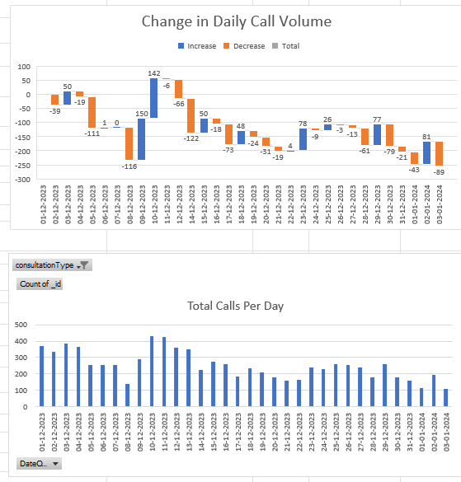

* The 1st chart represents the actual difference between call volumes per day.
* The 2nd chart represents the total call volumes per day.
* The call volume changes significantly from day to day.
* Big drops occurred (–122 on 14-dec, –116 on 8-dec), while spikes happened (+150 on 9-dec, +142 on 10-dec).
* On average, the call center handles **250 calls/day**.

**Insight:-**

The call volumes a quite unstable, require more agents to participate to handle the peak day calls

1. **Which months experienced the highest and lowest call volumes?**

Ans.

From the monthly call volume analysis:

* Highest – **December – 8090 calls**
* Lowest – **January – 418 calls**

**Insight:**

December is a high-demand period requiring more resources, while January is a low-demand month,

1. **What is total operational cost for that month?**

Ans. The total operational cost for

* December 2023: **₹73,925.84**
* January 2024: **₹3,873.60**
* Total for both months: **₹77,799.44**.

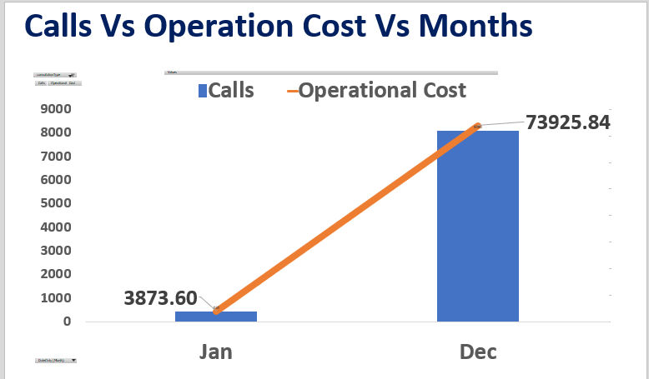

**Insight:**

Costs scale directly with call volume. High-volume months significantly drive operational expenses.

1. **What is the average number of calls handled per agent per day?**

Ans. Average number of calls handled are **2 calls per day per agent**

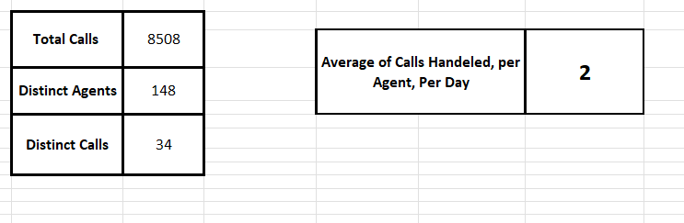

**Insight:**

Low utilization of agent’s workloads, needs to reanalyze the call distributions per agent per day.

1. **How many repeat callers are there, and what percentage of total calls do they represent?**

Ans.

**Steps: -**

1. Pivot table is filtered by **consultation type calls**
2. For each unique **uid:**
   1. **First call -** initial contact.
   2. **Subsequent calls -** repeat calls.
3. A **pivot table** was used to calculate the number of calls per uid, and then repeat calls were derived by ignoring the first call.
4. As you can see the **repeat callers are 4739** and **total calls are 8508**
5. So, by dividing both we get **56% of repeat callers**

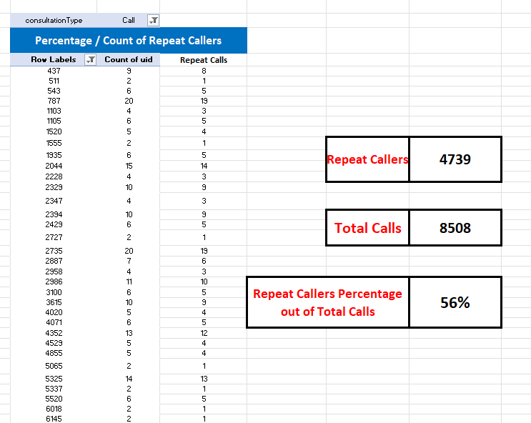

**Insight:**

Over half the total of calls are repeat calls, which clearly states the user calls again after the first call, due to same or related issues, so educating the agents to try solving the issues rather than dragging it for other calls, as it can lead to loss of reputation of the company.

1. **What are the total sales generated by the call centre for each product category?**

Ans.

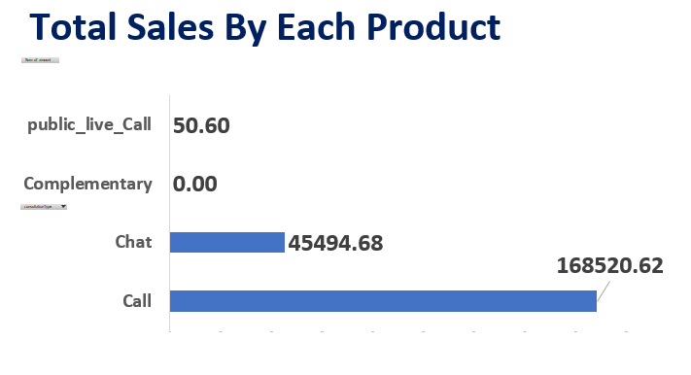

* Calls: **~79% of sales**
* Chats: **~21% of sales**.
* Public live call & complementary: **0% of sales**

**Insight:**

Revenue is **heavily dependent on call consultations**, requiring diversification to reduce risk.

1. **How many calls were made for each user id and guru id?**

Ans.

For both uid and gid total calls were **8508**

1. **What is the correlation between call duration and customer satisfaction?**

Ans.

Corelation is near to zero which indicates the clarity and quality of interaction which is more emphasized than call duration

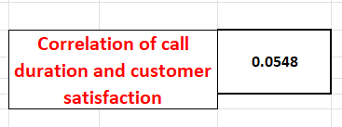

1. **Which guru has the highest and lowest customer satisfaction scores?**

Ans.

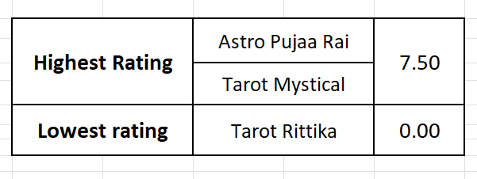

1. **What is average customer satisfaction score by month?**

Ans.

* December: **2.9**
* January: **2.7**

**Insight:**

Scores remain **consistently low (<3)** - urgent need to improve service quality.

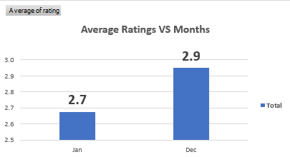

1. **How many categorical columns are there in the data?**

Ans. Categorical columns means non numeric columns, which are **15**

**Columns like: -**

Chatstatus, consultationtype, website, refundstatus, iswhitelistuser, queue, freecall, freechat, callchannel, callivrtype, callstatus, astrologercallstatus, region, usercallstatus, rating.

**Subjective Question:**

* 1. **Should the investment be used to hire more agents, improve training programs, or upgrade call centre technology?**

**My recommendation:** **Prioritise training and technology first, hire only if targeted gaps/peak staffing require it.**

**Why?**

* Average call duration is **116**, and the average load per agent per *active* day is **2 calls,** that indicates current staffing levels are not the limiting issue for most days.
* However, **4739 repeat users** generate **56% of call volume** ­:- i.e., a relatively small group of users drives a large chunk of load. Solving their issues (better service, faster resolution) is likely to reduce repeat calls.
* Overall **average rating** for calls is **2.9** (okay but improvable). Improving agent quality (training / QA) is likely to raise CSAT and reduce repeat calls.

**Recommended Action Plan: -**

1. **Training & quality (40%)**: - better call-handling, first-call resolution, cross-sell technique, and empathy -> will directly improve CSAT and reduce repeat-calls. Because agents appear under-utilized on average, improving quality is a high ROI move.
2. **Technology (35%)**: - invest in WFM (Workforce Management scheduling), IVR (Interactive Voice Response) routing, CRM (Customer Relationship Management) integration, callback/queue features, and chatbots. These reduce AHT (Average Handling Time), eliminate simple repeat calls, and help during peaks.
3. **Targeted hiring (15%)**: - hire temporary/part-time agents for sustained peak hours not broad hiring across all shifts.
4. **Incentives & retention (10%)**: - keep top-performing gurus motivated; retention reduces recruiting cost and maintains quality.
   1. **What are the potential risks of each investment option (hiring, training, technology upgrades), and how can they be mitigated?**

**Ans:-**

**A. Hiring**

* **Risks:** Overstaffing (waste of budget), temporary demand reduction, increased fixed payroll.
* **Mitigation:** Use WFM forecasting (hire contractors/part-time, trial hires). Hire only for measured peak hours
* **Excel tools:** Pivot Hour × Date heatmap; =CEILING () staffing model; data table for scenario analysis.

**B. Training**

* **Risks:** Short-term drop in throughput while agent’s train; training may not change behaviour without accountability.
* **Mitigation:** Stagger training, measure outcomes (before/after CSAT), combine with QA and coaching.
* **Excel tools:** Before/after pivot charts (Avg Rating by Guru pre/post training), paired t-test (or simple diff).

**C. Technology**

* **Risks:** Implementation complexity, vendor lock-in, integration delays.
* **Mitigation:** Pilot small, use measurable KPI’s (AHT, abandoned rate, CSAT) during pilot; vendor SLA review.
* **Excel tools:** ROI model (investment vs expected % AHT reduction -> revenue impact). Use Data Table or Scenario Manager.
  1. **How does astro-sage's call centre performance compare to Astro guru’s average call volume, customer satisfaction, and agent performance? Will you use any aggregation function or a visualization here to solve the problem?**

**Ans.**

For comparison of **Astro-sage** and **Astroguru** we don’t have any dataset of astroguru . Hypothetically if it was available we can easily perform the analysis by

1. **Harmonize columns** (Date, callsid, consultationtype, Rating, AHT, agentid).
2. **Compute normalized kpis:**
   * Avg calls / day, Avg CSAT, Avg AHT, Calls per agent per day.
3. **Visualize:**
   * Clustered bar chart comparing each KPI across companies.
   * Radar chart for multi-dimensional comparison (volume, CSAT, AHT, repeat-rate).
4. **Use statistical summary:** AVERAGE, STDEV.P, MEDIAN, and PERCENTILE.

**Excel functions/visualizations:** pivottable (side-by-side), Clustered Bar, Radar Chart, AVERAGEIFS.

**Interpretation approach:** Use normalized metrics per agent or per 1,000 customers (so size differences don’t bias view).

* 1. **How can the call centre improve its handling of peak call periods to ensure high customer satisfaction? Mention the functionality you will use for giving the suggestions, will it be any aggregated function or a visualization?**

Ans: -

Here we can clearly see from the graph where vertical axis represents the total calls and horizontal axis represents the peak hours.

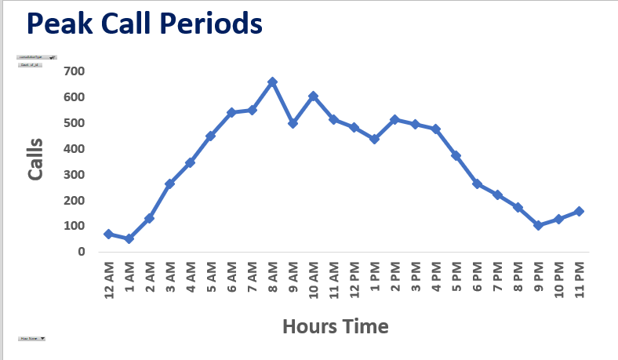

**What the data shows:** Peak hour is around **08:00**, with **600+ Calls** in that hour; other peaks around 10:00 and 11:00. With an average duration of **116.**

**Actions (operational + tech):**

1. **Staff scheduling**: Use WFM to add 1–2 extra agents in the 07:30–10:30 block (based on occupancy calculation).
   * Simple staffing formula:

$$\text{Agent-hours required}=\frac{\text{Calls/hour}×\text{AHT (seconds)}}{3600}$$

Then divide by target occupancy (e.g., 0.85) and round up.

1. **Callback & Virtual Queue**: Offer callback at peak to reduce abandoned calls and improve CSAT.
2. **IVR & Skill-based routing**: Direct high-value or repeat callers to senior agents.
3. **Chatbot triage**: Offload simple FAQs to chatbots to lower call volume.
4. **Real-time dashboards & thresholds**: Set alerts in Excel when queue length exceeds threshold.
   1. **Based on historical data, what strategic initiatives should be prioritized to improve efficiency and customer satisfaction?**

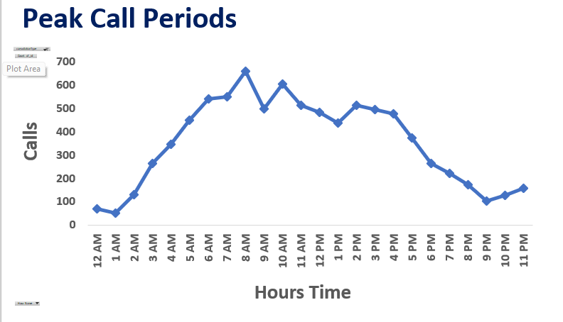

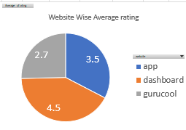

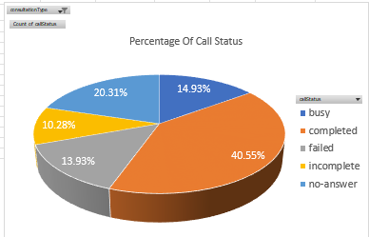

Based on the above visualisation i.e.

1. Peak Call Periods
2. Website wise ratings
3. Percentage of Call Status

**The call centre can adopt following strategies**

**Optimizing operational efficiency** -: The call centre can focus on allocating uniform number of calls to all the astrologers on a daily basis. They can do batching of a particular number of consultants and let the customer choose the consultant through a pre booking and remove them as soon as they get selected for a threshold value (like 10 calls a day). As per the availability of consultants.

**Improving customer satisfaction -:**

1. Technological update is a must to increase the quality of consultation so that the call completion ratio could be increased at least up to **60%** which is currently at **40%.** For a good customer review properly consulting and completing the call is very important.
2. Moreover, it’s important to have a backup consultant in case the assigned consultant cannot continue with call. Also, the organization should provide a free/discounted session if it gets cancelled or the consultant is not available.
3. They should focus on streamlining the chat process through chatbots for general queries based on the past records.
4. Quality program + incentives should be introduced to focus on the bottom 10% of gurus for coaching or reassignment.
   1. **What can be the key factors contributing to high customer satisfaction scores, and how can these be leveraged to improve overall performance? What is the basis for the suggestions? And mention how you decided if the satisfaction score affects the ratings.**

Ans.

**What the data shows:**

* Overall call Customer Satisfaction score is 2.9 and small variation occurs across call statuses and small to no correlation occurs between Average Handling time and customer relation (correlation is **0**). That means **longer calls are not necessarily happier calls** here.
* For high Customer Satisfaction look at top-rated gurus: *Tarot Mystica, Astro Pujaa Rai and* replicate their behaviours.

**Likely key factors to test & leverage:**

1. **First-call resolution**: - Reduce repeat calls for the same problems, try solving it in the first call itself (Use userid grouping to identify frequent repeat issues.)
2. **Agent expertise / approach**: - Replicate top agents’ scripts/approaches and try educating other agents.
3. **Handling of peak times**: - Negative customer experiences often happen when wait times are long, so avoid long waiting time.
   1. **How should the call centre balance the workload among agents to ensure optimal performance and avoid burnout? Mention your approach and spreadsheet function for the answer.**

**Ans: -**

To ensure optimal performance and avoid burnout, the call centre should focus on **equal workload distribution** among agents based on the **average number of calls handled per agent per day**.

From the analysis, it is observed that some agents such as **Dr. Shalini** handle significantly more calls than the average baseline, while others manage much fewer. This uneven distribution can lead to **agent fatigue**, reduced quality of service, and **inefficient resource utilization**.

**Approach:**

1. **Calculate the Average Calls for top 10 Agents** 
   * The Average Calls are 278
   * Using this formula (=AVERAGE (range_of_calls))

This gives the **baseline workload** for comparison.

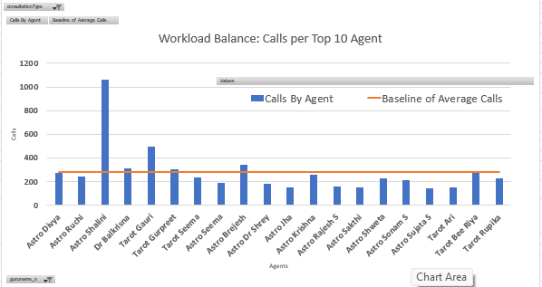

1. **Compare Individual Agent Workload Against the Average**
   * To find the workload deviation for each agent:
   * =Calls_By_Agent - Average_Calls
     + **Positive value:** Agent is overburdened (above baseline).
     + 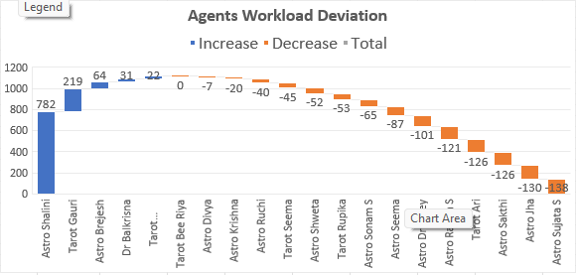**Negative value:** Agent is underutilized (below baseline).
2. **Redistribute Workload:**
   * Assign excess calls from overburdened agents to underutilized ones.
   * Adjust shift timings or incoming call routing based on these findings.

* Now Based on this data re-educate the Overburdened Agents to maintain the workload Balance, to avoid burnout and Ensure Optimum Performance.
* And Also Educate the under performing Agents To at least reach the base line to maintain good performance, and incentives can be a motivation to achieve it.
  1. **What new technologies or tools could be implemented to enhance call centre operations and customer service?**

**Ans**

* Machine Learning (ML) algorithms can analyse past call patterns to predict peak times and optimize scheduling.
* The call centre can adopt ai-powered call routing to automatically direct calls to the most suitable agents based on skills, language, and performance.
* Predictive analytics can be used with Excel’s FORECAST.LINEAR() function to forecast daily or monthly call volumes.
* Implementing a Customer Relationship Management (CRM) system such as Salesforce or Zoho CRM can help store and track customer data and improve personalized service.
* Chatbots and voice assistants can handle repetitive customer queries, reduce agent workload and improve response time.
* A real-time analytics dashboard can be built using Excel’s Power Query, Power Pivot, and Power BI to visualize metrics like call volume, satisfaction scores, and agent performance.
* Cloud-based communication platforms like Twilio, Amazon Connect, or Genesys Cloud can manage calls, messages, and chats efficiently from any location.
* Automation through Excel functions like VLOOKUP () and IF () can simulate smart call routing by matching customer query types with agent specialization.
* Pivot Tables can summarize call data to identify workload imbalances and performance trends.
* Adopting these technologies will enhance efficiency, improve customer satisfaction, and prevent agent burnout.
  1. **What metrics should be included in the final dashboard to comprehensively view call centre performance and guide investment decisions?**

**Ans: -**

To provide a complete and actionable view of Astro-Sage’s call centre performance, the dashboard integrates a mix of **operational, financial, and customer-centric metrics**. Each metric has been carefully selected to align with the company’s strategic goals of optimizing efficiency, and improving customer satisfaction

The final dashboard includes the following key metrics and visual components:

* **Key Performance Indicators**

1. **Total Calls & Total Chats** –  
   These metrics represent the overall communication volume handled by the call centre. They give a direct understanding of workload distribution between call and chat operations, helping assess staffing and capacity requirements.
2. **Cost per Call** –  
   This metric helps evaluate the financial efficiency of operations by comparing total operational expenses with total call volume. It guides investment decisions by identifying whether resources are being optimally used or if cost reduction strategies are needed.
3. **Average Daily Calls** –  
   These measures the average inbound traffic per day, indicating the typical daily workload. It helps in forecasting staffing needs and planning shifts efficiently.
4. **Repeat Callers (%)** –  
   This shows how many users are reaching out multiple times, reflecting customer retention and satisfaction levels. A higher repeat rate may indicate ongoing engagement or unresolved issues, requiring further analysis.
5. **Average Rating (Customer Satisfaction)** –  
   These measures the overall quality of service delivered by astrologers. It is a key performance indicator for understanding user satisfaction, service consistency, and agent effectiveness.

* **Performance Charts**

1. **Calls vs Operational Cost (Trend by Month)** –  
   A combination chart showing how call volume and cost change over time. This helps in identifying whether increasing calls correspond to increasing costs, or if productivity is improving.
2. **Percentage of Call Status** –  
   A pie chart visualizing the distribution of call outcomes (Completed, Busy, Failed, Incomplete, No-Answer). This highlights operational bottlenecks and agent efficiency in converting incoming requests into successful consultations.
3. **Peak Call Periods (Hourly Trend)** –  
   A line chart displaying call distribution by time of day. It helps in planning agent shifts and ensuring that more astrologers are available during high-demand hours.
4. **Total Sales by Each Product**

A bar chart displaying revenue generated by each product type (Call, Chat, Public Live Call, etc.). It identifies top-performing services and supports investment decisions for product development and marketing.

1. **Website Distribution (App, Dashboard, Gurucool)** –  
   This shows which platform users prefer for consultations. It informs marketing and technology investment decisions based on user behaviour trends.
2. **Workload vs Average Baseline (Top 10 Agents)** –  
   This chart compares each astrologer’s call handling volume with the average workload (baseline of 278 calls). It identifies workload imbalance, helping prevent burnout and optimize staff scheduling.
3. **Rating by User Call Duration** –  
   A horizontal bar chart that correlates average call duration with customer rating. It helps understand whether longer consultations lead to higher satisfaction or reduced efficiency.
4. **Top 10 Highest and Lowest Rated Gurus** –  
   These visuals rank astrologers based on user feedback. They highlight the top performers for recognition and identify those needing further training or quality improvement.
   1. **How would you allocate a 1 crore rupee investment to optimize operational efficiency, enhance customer satisfaction, and boost profitability, and what analysis-based recommendations would you offer to support this? [you have to give bullet pointers to answer this question]**

**Ans:-**

Based on the complete dashboard analysis of Astro-Sage’s call centre performance, the ₹1 crore investment should be strategically allocated across key operational and customer-focused areas to maximize impact.

1**. Agent Optimization and Training: -₹25 Lakhs**

* Conduct skill-based training programs for astrologers to improve communication, accuracy, and consultation quality.
* Use insights from the *Rating by Guru* and *Rating by Call Duration* charts to identify underperforming astrologers for targeted coaching.
* Introduce performance-based incentives to boost motivation and productivity.

**2. Technology and Infrastructure Upgrade: -₹20 Lakhs**

* Invest in advanced call management systems (IVR, call routing, auto-callback features) to reduce failed or missed calls seen in the *Call Status* chart.
* Enhance server infrastructure and implement AI-based chatbots for handling basic customer queries, reducing workload on astrologers.
* Integrate real-time analytics tools to monitor call trends and service quality.

**3. Hiring and Workforce Expansion: - ₹15 Lakhs**

* Based on the *Workload vs Baseline* and *Peak Call Periods* charts, hire additional astrologers for high-demand hours.
* Maintain an on-demand resource pool to handle seasonal traffic spikes efficiently without increasing fixed costs.

**4. Marketing and Customer Retention Initiatives: -₹15 Lakhs**

* Use data from *Repeat Callers* and *Website Distribution* charts to design targeted loyalty programs and personalized offers for frequent users.
* Launch digital campaigns promoting top-performing services (identified in *Total Sales by Product*).
* Collaborate with influencers and social media campaigns to expand reach and improve brand visibility.

**5. Product Enhancement and Diversification: -₹10 Lakhs**

* Enhance high-revenue services like *Call Consultations* while refining low-performing products such as *Chat* and *Public Live Calls*.
* Introduce combo offers or subscription plans to increase transaction frequency and user retention.
* Use dashboard insights to reprice underperforming products for better profit margins.

**6. Quality and Customer Experience Improvement: -₹10 Lakhs**

* Deploy post-call feedback systems to monitor customer satisfaction in real time.
* Implement AI-based sentiment analysis on chat/call transcripts to identify service gaps.
* Regularly review customer complaints and ensure prompt redressal to strengthen trust.

**7. Monitoring, Reporting & Continuous Improvement: -₹5 Lakhs**

* Set up a centralized analytics dashboard for real-time performance tracking using Power BI/Excel automation.
* Schedule monthly KPI reviews based on metrics such as *Cost per Call*, *Average Rating*, and *Operational Cost vs Calls*.
* Use predictive analytics to forecast future workloads and resource needs.
* **Expected Outcomes**
* Operational Efficiency: 20–25% reduction in idle time and call drop rates.
* Customer Satisfaction: Expected improvement of 15–20% in average rating and repeat engagement.
* Profitability: Cost per call reduced, revenue per call increased through optimized workforce and product focus.